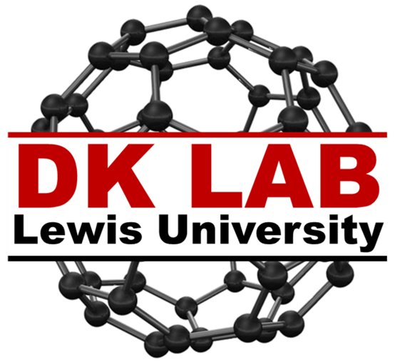

This application will be used by members of DK Lab, a chemistry research group at Lewis University, to track work and log time on instruments

By: Danny Maurer

# **Overview**

## Purpose

DK Lab is a chemistry focused research group on the campus of Lewis University. This lab is made up of Undergraduate and Graduate students, with its focus on giving as many students possible experience in the lab. Because of this goal, booking instrument time is essential to the success of a researcher and project due to the number of students vying for a chance to experiment. Currently, there is a laminated sheet of paper or log book next to each instrument that students book their experiment time. The purpose for this application is to allow students to book and view instrument time without having to physically be at the instrument. This application will also display the process of record (POR) for each instrument for instructions and troubleshooting.

## How it works

# **Market Analysis**

## Similar Applications

### TSheets

This application works as a digital time sheet. An employee will clock in, and the application will track working hours, location throughout shift, and access to team hours. The focus of this application is more for employee tracking rather than instrument tracking.

### Asset & Inventory Tracker

This application allows a user to track assets and inventory in real-time by scanning a 2D barcode and sending data to a web server. The application allows a user to adjust tags, check in or out with geotag locating, and view maintenance and reservation history or company assets. Users are also able to specify questions that must be answered when an asset is scanned and take pictures of the state of the asset. The focus of this application is more on the tracking of specific inventory and where it is located but has functionality for tracking status and history.

## Individualities

What makes the DK Lab application unique is that the tracking is specific to instruments in the lab. Applications like Asset & Inventory Tracker have similar functionality; however the focus of the application is generic. This proposed application will be specific to the members of DK Lab, so the interactions will be more user friendly for the specific use.

# **Functions**

## Instrument Booking

This functionality will allow for a student to book an instrument for a duration of time on a specific date. The student will also be able to see what other times this instrument is booked for as well as who made the request.

## Instrument History

This functionality will allow for a student to view the history of an instrument. The information included will be date, time, and user with optional notes on how the instrument was running or problems that occurred.

## Instrument Resources

This functionality will allow for a student to gain additional information on the specific instrument. This will include data sheets or lab POR’s to allow for a student to trouble shoot any information or improve the process of data collection.

# **Mock-ups**

## Instrument List

## A screenshot of a social media post Description automatically generatedInstrument Activity

## Instrument Booking

## Instrument History

## A screenshot of a cell phone Description automatically generatedInstrument Resources